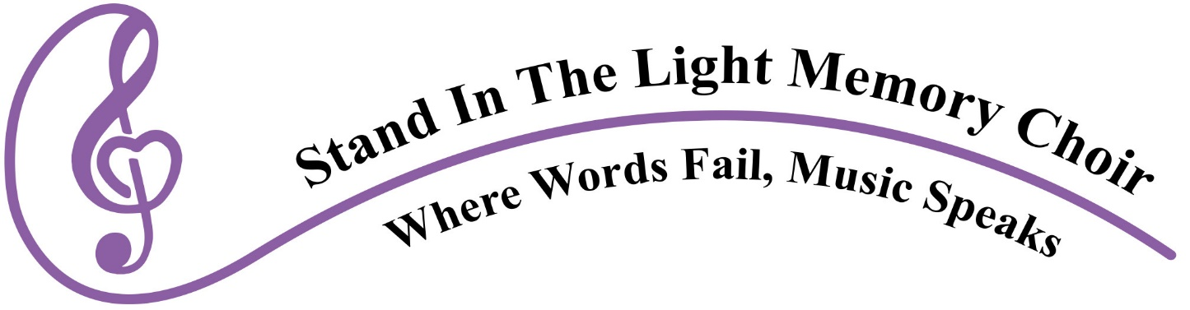

The Stand in the Light Memory Choir uses the power of singing to move people with memory loss and their care partners to rediscover themselves, make new friends, laugh together, and contribute to their community.

Board of Directors Job Description
- Attend board meetings
- Be on at least one committee
- Assist in fundraising efforts through contributions, identifying possible donors, securing sponsorships and helping to write grants
- Support the mission statement of “Stand in the Light Memory Choir”
- Represent the organization well to the public
- Remain in board position for entire 2 year term
- Assist with development of yearly recruitment process
- Assist with public performances and other Board activities when needed
- Knowledge of 501(c)(3) organization (not necessary, but highly recommended)
- Basic computer literacy

If interested, contact by June 30: standinthelightchoir@gmail.com

